**Scale Construction Study #1**

Please read the following 8 statements:

1. People can do things differently, but their status in society can’t really be changed.
2. Everyone, no matter who they are, can significantly change their status in society.
3. The status a person has in society is something basic about them, and it can’t be changed very much.
4. People can substantially change their status in society.
5. No matter what status a person has in society at one point in their life, they can always change it a lot.
6. People can change even their most basic status markers.
7. Everyone is of a certain status in society, and there is not much that they can do to really change that.
8. As much as I hate to admit it, people can’t really change where they stand in society at large.

Please indicate what terms like “status in society,” “the status a person has in society,” “where people stand in society at large,” and “status markers” MEAN TO YOU, as they appear underlined in the above statements. In other words, what do terms like these make YOU think of, and how would YOU define them?

**Scale Construction Study #2**

|  |  |  |  |  |  |  |
| --- | --- | --- | --- | --- | --- | --- |
| 1 | 2 | 3 | 4 | 5 | 6 | 7 |
| Strongly disagree | Disagree | Somewhat disagree | Neither agree nor disagree | Somewhat agree | Agree | Strongly agree |

**Lay theories of personality (gen1r through gen8r):**

1. Everyone is a certain kind of person, and there is not much that they can do to really change that. (R)
2. People can change even their most basic qualities.
3. The kind of person someone is something basic about them, and it can’t be changed very much. (R)
4. Everyone, no matter who they are, can significantly change their basic characteristics.
5. People can substantially change the kind of person who they are.
6. No matter what kind of person someone is, they can always change very much.
7. As much as I hate to admit it, you can’t teach an old dog new tricks. People can’t really change their deepest attributes. (R)
8. People can do things differently, but the important parts of who they are can’t really be changed. (R)

**Perceptions of socioeconomic mobility (itss1r through itss8r):**

1. People can do things differently, but their status in society can’t really be changed. (R)
2. Everyone, no matter who they are, can significantly change their status in society.
3. The status a person has in society is something basic about them, and it can’t be changed very much. (R)
4. People can substantially change their status in society.
5. No matter what status a person has in society at one point in their life, they can always change it a lot.
6. People can change even their most basic status markers.
7. Everyone is of a certain status in society, and there is not much that they can do to really change that. (R)
8. As much as I hate to admit it, people can’t really change where they stand in society at large. (R)

**Lay theories of intelligence (iti1r through iti8r):**

1. People have a certain amount of intelligence and they really can’t do much to change it. (R)
2. No matter who are you, you can significantly change your intelligence.
3. A person's intelligence is something about them that they can’t really change very much. (R)
4. A person can always substantially change how intelligent they are.
5. No matter how much intelligence a person has,  they can always change it quite a bit.
6. A person can change even their basic intelligence level considerably.
7. People can learn new things, but they can’t really change their basic intelligence. (R)
8. To be honest, people can't really change how intelligent they are. (R)

**Attention check (check1-check4):**

* This item is here to screen out random responding; do not give a response to this item. (x4)

**Age:** ____________

**Gender:**

1. Male
2. Female

**Study 1**

|  |  |  |  |  |  |  |
| --- | --- | --- | --- | --- | --- | --- |
| 1 | 2 | 3 | 4 | 5 | 6 | 7 |
| Strongly disagree | Disagree | Somewhat disagree | Neither agree nor disagree | Somewhat agree | Agree | Strongly agree |

**Perceptions of socioeconomic mobility (ltss1r through ltss6):**

These next questions will ask you how you feel about your status in society, meaning how much money you and your family have, the kind of jobs you can have, and how you describe your place in society (lower class, middle class, or upper class). Please read each sentence below and select the response that shows how much you agree or disagree with it. Be honest about how you feel – there are no right or wrong answers!

1. You have a certain status in society, and you really can’t do much to change it. (R)
2. Your status in society is something about you that you can’t change very much. (R)
3. You can do things differently, but you can’t really change your status in society. (R)
4. No matter who you are, you can significantly change your status a lot.
5. You can always greatly change your status in society.
6. No matter what your status is at one point in your life, you can always change it quite a bit.

**Psychological inclinations to persist academically (diff.imposs1 through diff.imposs4):**

1. If working on a school task feels very difficult, that type of task may not be possible for me. (R)
2. Sometimes people work at things that just aren’t meant for them. If a school task feels too difficult, I should move on to something else. (R)
3. If a school task feels really difficult, it may not be possible for me. (R)
4. When I feel stuck on a school task, it's a sign that my effort is better spent elsewhere. (R)

**Lay theories of intelligence (lti1r through lti6):**

1. You have a certain amount of intelligence, and you really can’t do much to change it. (R)
2. Your intelligence is something about you that you can’t change very much. (R)
3. No matter how much intelligence you have, you can always change it quite a bit
4. You can always greatly change how intelligent you are.
5. You can learn new things, but you can’t really change your basic intelligence. (R)
6. No matter who you are, you can always change your intelligence a lot.

**Gender:** ____________

**Age:** ____________

**Grade:**

1. 9th grade
2. 10th grade
3. 11th grade
4. 12th grade

**Variable collected from school administrative records:**

* gpa

**Study 2**

**What school do you attend? (school.x, coded as collegetype)** ____________

**What year of your academic program are you in? (year)**

1. Freshman
2. Sophomore
3. Junior
4. Senior
5. Graduate student
6. Adult student / mature student / returning student
7. Other

**Manipulating perceptions of socioeconomic mobility:**

On the next few pages, you will be presented with a series of statements. Your task will be to indicate your agreement with each statement using the response options provided.

PLEASE NOTE: Our server is running a bit slow at the moment, so it may take a few seconds for each page to load. We thank you for your patience.

|  |  |  |  |  |  |
| --- | --- | --- | --- | --- | --- |
| 1 | 2 | 3 | 4 | 5 | 6 |
| Agree somewhat |  |  |  |  | Agree completely |

***Weak socioeconomic beliefs condition (entity1 through entity4):***

1. People can do things differently, but their status in society can’t really be changed.
2. The status a person has in society is something basic about them, and it can’t be changed very much.
3. People cannot substantially change their status in society.
4. The status a person has in society at one point in their life is likely the same status that they will have at a latter point in their life.

***Strong socioeconomic beliefs condition (incremental1 through incremental4):***

1. Just by doing a few things differently, people can greatly change their status in society.
2. The status a person has in society is something very flexible about them, and it can change a lot.
3. People can substantially change their status in society.
4. No matter what status a person has in society at one point in their life, they can always change it a lot.

***In both conditions, for 8 second between each item:***

* Our server is currently experiencing a delay, but should respond within 10 seconds. We appreciate your patience.

**Academic persistence anagram task (anagramwords, correctwords, totalwords):**

*Page 1:* Next, we would like you to complete and evaluate an activity that has been used in the past with college students. The task’s purpose is to evaluate students’ learning styles.

*Page 2:* You will be presented with seven letters, which you must unscramble to form real English words. Your goal is to generate as many words as possible. The words must be at least 3 letters long, and no letter can be used twice in a single word. You have 3 minutes to work on this task. When you are ready to begin, press the >> button.

*Page 3, which includes a visible 3-minute countdown timer and an open-ended response box:* The letters are: L C R A E K G. Please type your answers below, separated by commas.

***Response scale for next 3 measures:***

|  |  |  |  |  |  |  |
| --- | --- | --- | --- | --- | --- | --- |
| 1 | 2 | 3 | 4 | 5 | 6 | 7 |
| Strongly disagree | Disagree | Somewhat disagree | Neither agree nor disagree | Somewhat agree | Agree | Strongly agree |

**Manipulation check (itss1 through itss4r):**

1. Everyone, no matter who they are, can significantly change their status in society.
2. Everyone is of a certain status in society, and there is not much that they can do to really change that. (R)
3. People can change even their most basic status markers.
4. As much as I hate to admit it, people can’t really change where they stand in society at large. (R)

**Lay theories of intelligence (lti1r through lti3r, measured as in Study 1)**

**Attention checks (dircheck1 and dircheck2):**

* This item is here to screen out random responding; do not give a response to this item.

**Subjective SES measure (ladder, measured as in Study 1)**

**What is your family's annual household income? (income)**

1. $25,000 or less
2. $25,001-$40,000
3. $40,001-$70,000
4. $70,001-$90,000
5. $90,001-$120,000
6. $120,001-$150,000
7. $150,001-$200,000
8. $200,001-$300,000
9. $300,001 or more

**What is your gender? (gender)**

1. Male
2. Female

**Study 3**

**Manipulating perceptions of socioeconomic mobility:**

Please study the figure below that contains information about American society and answer the questions below.

***Weak mobility beliefs condition (Fixed):***

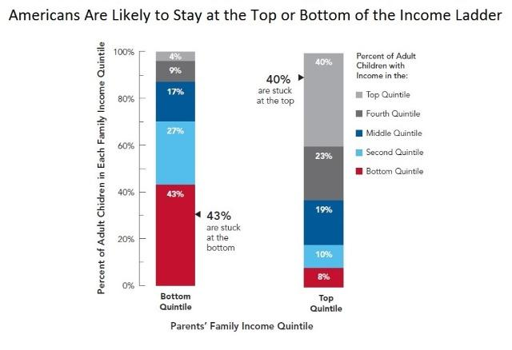

***Strong mobility beliefs condition (Growth):***

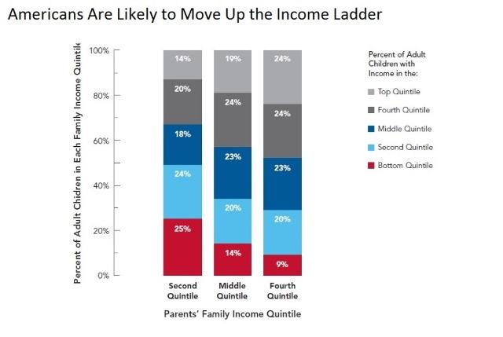

***Control condition (control):***no materials

***Attention checks in both conditions (Check.1a, Check.1b, Check.2a, Check.2b):***

* According to the figure above, is the following statement True or False? Many Americans are stuck where they came from, at the bottom or top of society.
* According to the figure above, is the following statement True or False? Most Americans move up in society.

**Psychological inclinations to persist academically (persist1 through persist6):**

1. When I feel stuck on a school task, it’s a sign that my effort is better spent elsewhere. (R)
2. If working on a school task feels very difficult, that type of task may not be possible for me. (R)
3. Sometimes people work at things that just aren’t meant for them. If a school task feels too difficult, I should move on to something else. (R)
4. I know that when working on a school task feels hard, that feeling means it’s not for me. (R)
5. Finding a school task really difficult tells me that I can’t complete it successfully. (R)
6. If a school task feels really difficult, it may not be possible for me. (R)

**Subjective SES measure (LadderUS, measured as in Study 1)**

**What is your age? (Age)** ____________

**What is your gender? (Gender)**

1. Male
2. Female

**What is your race? Select as many as apply (Race_1 through Race_7)**

1. American Indian, Native American, Alaska Native
2. Asian or Asian American
3. Black, African American, African
4. Latino or Latina
5. Middle Eastern or Arab
6. Native Hawaiian or Other Pacific Islander
7. White or Caucasian

**Variables collected from school administrative records:**

* MedianIncome_BlockGroup
* gpa

**Supplementary Study**

**What is your sex? (In.SexElig)**

1. Male
2. Female

**How old are you? (In.Age)** ____________

**What is your race? Check all that apply. (In.Race.1 through In.Race.6.TEXT)**

1. African American/Black
2. Asian American/Asian
3. Caucasian/White
4. Hispanic/Latino/a

6. Other (please specify)

**What year in school are you? (In.Year)**

1. Freshman
2. Sophmore
3. Junior
4. Senior
5. Graduate Student
6. Other (please specify)

**What is your mother’s / father’s average yearly income? (In.MIncome, In.MHIncome, In.Fincome, In.FHIncome)**

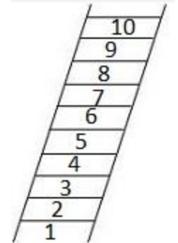**Subjective SES measure (W5.SubSES2):**

Think of this 10-rung ladder as representing where people stand in society. At the top of the ladder are the people who are the best off – those who have the most money, the most education, and the most respected jobs. At the bottom are the people who are the worst off – who have the least money, least education, and the least respected jobs or no job. The higher up you and your family are on this ladder, the closer you and your family are to the people at the top; the lower you and family are, the closer you and your family are to the people at the very bottom. Please indicate where you feel you and your family stand relative to people in the United States at large.

**Perceptions of socioeconomic mobility (ltss1r through ltss8r; measured as in Scale Construction Study #2)**

**Lay theories of intelligence (lti1r through lti3r):**

1. You have a certain amount of intelligence, and you can’t really do much to change it. (R)
2. No matter who you are, you can significantly change your intelligence level.
3. You can learn new things, but you can’t really change your basic intelligence. (R)

**Protestant work ethic beliefs (pwe1 through pwe4r):**

1. If people work hard they almost always get what they want.
2. If people work hard enough, they can be whatever they want to be in life.
3. Getting ahead in life doesn’t always depend on hard work. (R)
4. Even if people work hard, they don’t always get ahead. (R)